III YEAR–II SEM TEAM PROJECT LAB REPORT

on

AUTOMATED LIGHTING SYSTEM

Department of Electrical and Electronics Engineering

19B81A0218 N.Nishith

AY: 2021-2022

CVR COLLEGE OF ENGINEERING

Vastunagar, Mangalpalli (V), Ibrahimpatnam (M),

R.R. District Pin code: 501510

CVR COLLEGE OF ENGINEERING

(An UGC Autonomous Institution with NAAC ‘A’ Grade)

Vastunagar, Mangalpalli (V), Ibrahimpatnam (M), R.R. District

Ph.No:91-8414 – 661601, 661675

DEPARTMENT OF ELECTRICAL AND ELECTRONICS ENGINEERING

CERTIFICATE

This is to certify that this Team Project Lab Report entitled “AUTOMATED LIGHTING SYSTEM” by N.Nishith Roll No. 19B81A0218, submitted in partial fulfilment of the requirement for the degree of Bachelor of Technology in Electrical and Electronics Engineering of the CVR College of Engineering, Hyderabad, during the academic year of 2021-22s, is a bonafide record of the work carried out under our guidance and supervision.

The results embodied in this report have not been submitted to any other University or Institution for the award of any degree or diploma.

Mrs. K. Deepika Mr. K.S.V. Phani Kumar Dr. S. Venkateshwarlu

Lab In charge Lab In charge

Assistant Professor, EEE Sr. Assistant Professor, EEE (Professor & HOD, EEE)

**ABSTRACT**

In today’s world where energy management and conservation are a talked subject and especially “Automated home lighting system” is one such area which is gaining lot of attraction in lighting industry.

For high efficiency, long lifetime, better light quality, fluorescents, and LEDs are becoming more reliable in lighting technology. Adding MCUs and sensors to the lights further boost its superiority.

Selective turn on/turn off results in increased system life and reduce energy consumption. This project is about smart home lighting based on Passive Infrared sense. In today’s world where energy management and conservation are a talked subject and especially “Automated home lighting system” is one such area which is gaining lot of attraction in lighting industry.

**Roll Number Name Signature**

**19B81A0218 N.Nishith**

**INDEX**



Chapter – 1: INTRODUCTION:

Nowadays, energy consumption is large in residential and business areas. it's due to the inefficient usage of electrical loads like heating systems, lighting systems etc. Among these, the lighting system is one in all the biggest energy overwhelming units of any building & structure. it's thus crucial to use the good lighting system by automatically switch on/off or dim the lights when required without troubling the conventional operation of the working atmosphere. Nowadays, energy consumption is large in residential and business areas. it's due to the inefficient usage of electrical loads like heating systems, lighting systems etc. Among these, the lighting system is one in all the biggest energy overwhelming units of any building & structure. it's thus crucial to use the good and efficient lighting system by automatically switch on/off or dim the lights when required without troubling the conventional operation of the working atmosphere.

Different fields of lighting are business, residential, industrial, and outside lighting. each of the sector has its own desires and necessities of lighting using completely different sensors. Residential sector wants to low power therefore low-price easy solution will be used by using ambient sensors. Industrial lighting in retailers and offices uses bit high power, so they will create use of passive infrared sensors or supersonic sensors to cover massive areas. outside and Industrial sectors will create use of Pyroelectric Infrared(PIR), light and motion sensors so as to manage the light in a very safety and value effective manner.

In many cases we found that people just forget to put off the lights before they are leaving. Automatic lighting system is a system where the light will become ON sensing if there is any movement in the room. If there is any movement in the room the light will become ON. If there is no movement in the room for a long time the light will be OFF. We can use any kind of electrical equipment instead of light. Lots of other things are producing day by day for this purpose.

Chapter – 2: MANAGERIAL

2.1 Budget of the product

Budget of the project - ₹554

2.2 Bill of materials

2.3 Finance options used

Investment is done by me

**2.4 The actual timeline followed**

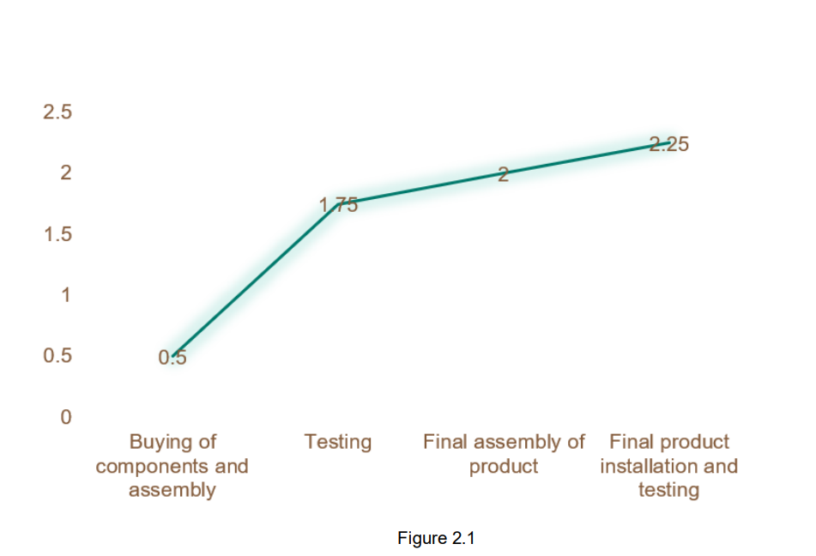

The above timeline graph represents the time taken to complete each phase of the product in months. We took half month for buying components and assembly, one month and a week for testing, one week for final assembly of the product and one week for final product installation and testing.

**2.5 Target customer**

This product is made by targeting the middle-class household people. This product is made to reduce the consumption of electricity by turning on the lights in staircases and balcony. Our product is economical. So, it attracts our targeted customers.

**2.6 Price of the product**

The price of the product is ₹650.

**2.7 Expenditure made in different phases of the project**

1. Buying Components - ₹404

2. Testing - ₹0

3. Outer Body Manufacturing - ₹150

**2.8 Commercial aspects of the project**

● As the total investment of our project is equally invested by team members, so the profits earned are also shared equally among the team members.

● For 1000 units, revenue generated will be ₹6,50,000.It earns a profit of 96,000.

Chapter – 3: TECHNICAL

**3.1 Introduction**

A motion detector is a device that detects moving objects especially people. It is often integrated as a component of a smart system to receive alerts. It contains a Pyroelectric sensor which is an optical sensor that senses the moving object through emission or reflection of infrared rays. It is sensitive to a person's skin temperature through emitted black body radiation at mid-infrared wavelengths, in contrast to background objects at room temperature.

PIR Sensors has a 3-pin circuit, one is the ground pin, other is the supply voltage pin generally 5V and the third pin is the output signal pin. The PIR sensor board results in a digital output which we recognize as a pin having a flip from low to high or high to low. It is difficult to differentiate between different energy emitting bodies like humans, animals, moving objects, heat emitting bodies, etc. Thus, a potentiometer is generally used to tune the frequency of the input system to that of the emitting source to be selective. Once the moving body is out of the range of the detection of the sensor, it results in a low signal indicating the absence and thus system goes to a standby state waiting for an input radiation.

**3.2 Working of PIR sensor**

Any object be it living or non-living emits radiations due to its heat. In case of humans or animals, IR radiations are emitted because of body heat.

The Fresnel lens captures these rays and focuses them onto the pyroelectric element as shown in figure 3.

The infrared rays from the person are focused on the sensing element and thus detected.

**3.3 Circuit diagram**

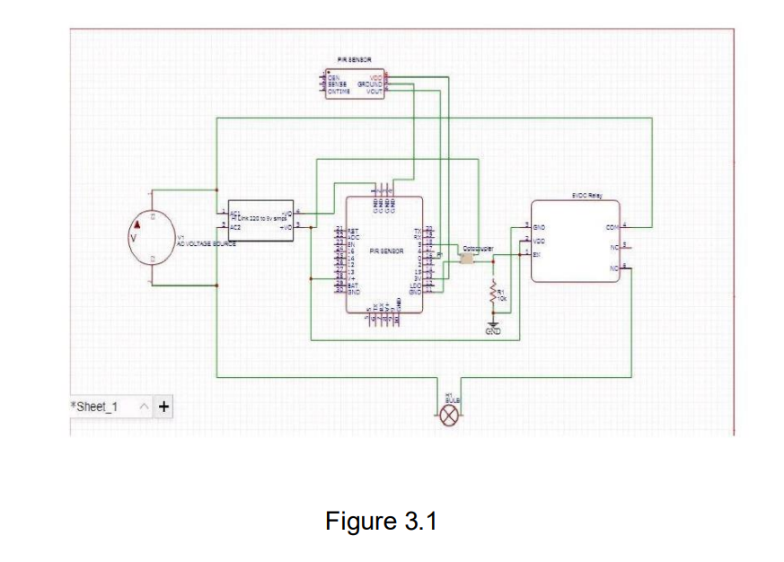

**3.4 Technical options considered to do the project**

The Automatic Room Lights using esp8266 and PIR Sensor, where the lights in the room will automatically turn on upon detecting a human motion and stay turned on until the person has left or there is no motion.

Initially, when there is no human movement, the PIR Sensor doesn’t detect any person and its OUT pin stays LOW. As the person enters the room, the change in infrared radiation in the room is detected by the PIR Sensor.

As a result, the output of the PIR Sensor becomes HIGH. Since the Data OUT of the PIR Sensor is connected to Digital Pin 8 of esp8266, whenever it becomes HIGH, Arduino will activate the relay by making the relay pin LOW (as the relay module is an active LOW module).This will turn the Light ON. The light stays turned ON for 10-15seconds when there is movement in front of the sensor.

If the person takes a nap or leaves the room, the IR Radiation will become stable (there will be no change) and hence, the Data OUT of the PIR Sensor will become LOW. This in turn will make the esp8266 to turn OFF the relay (make the relay pin HIGH) and the room light will be turned OFF.

In our project automation of lighting can also be done without using a microcontroller the main functionality of node mcu is to detect the high pulse from the digital pin of pir sensor and based on that it actuates a signal to the relay. Instead pir module can be used as a control unit by itself in this project by adjusting the delay settings on the pir the turn on time of the relay can be varied. But the problem with this arrangement is pir digital out pin outputs a signal of 2.7volts in order to turn on a relay we require 3.3v to increase the voltage level we can either use an opamp circuit or we can use an optocoupler circuit where the digital signal is used to turn on the photodiode to give a 5volts signal to the digital pin of the relay.

REFERENCES:

1. [A Beginner's Guide to the ESP8266 (tttapa.github.io)](https://tttapa.github.io/ESP8266/Chap04%20-%20Microcontroller.html#:~:text=Voltage%20and%20current%20restrictions,single%20GPIO%20pin%20is%2012mA)
2. [MCT2 Datasheet | QT Optoelectronics - Datasheetspdf.com](https://datasheetspdf.com/datasheet/MCT2.html)

**Chapter – 4: DESIGNING**

**4.1 System block diagram**

**4.2 Comparison of different designs**

**4.3 Prototype and dimensions**

Product dimensions **8x6x6 cm**

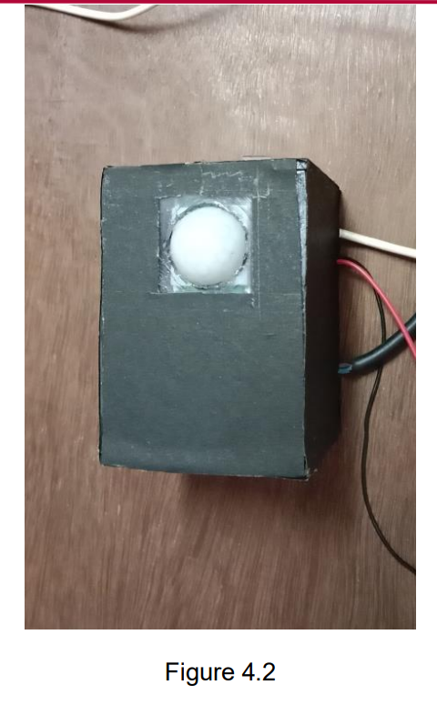

**4.4 Product shape**

The shape we chose is rectangular shape. Rectangular shaped outbox is easy to build, and it is easy to install on roof top or wall. Rectangular shape of product keeps the components in place.

**4.5 Views**

The following figures show the different views of the product.

**Top view**

**Side view**

**Bottom view**

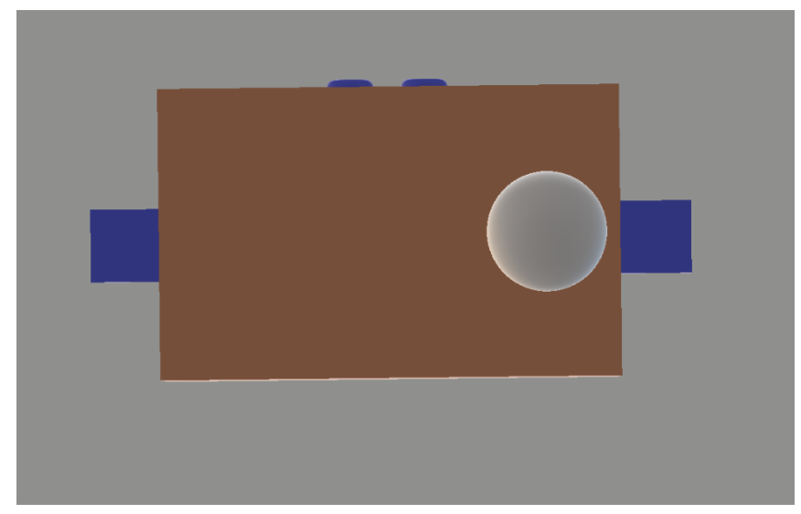

**Front view**

**Back view**

**4.6 Installation method**

The product is installed to the roof top using the screws . screw holes are arranged to install it using screws.

**4.7 Inside view**

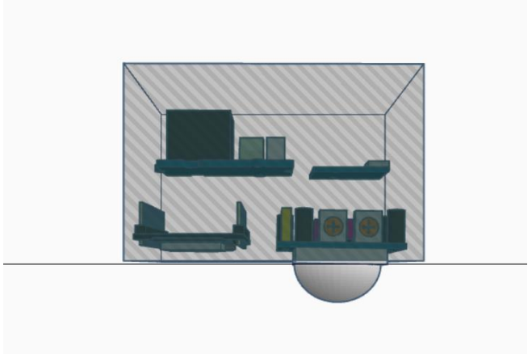

**4.8 Conclusion**

From the proposed system we can conclude that an approach is taken to control the room lights using various devices. As nowadays enormous amount of energy is wasted in daily life. With the help of this system the energy wastage can be preserved and can be contribute to large amount of power saving. The total effective cost of system is very less.